Database Design Document

**1. Introduction**

This document outlines the design and structure of the "Whole Sale System" database. The system is intended to streamline wholesale operations, including product management, customer information, transactions, and payments. It encompasses various tables, procedures, triggers, and constraints to ensure efficient data management and integrity.

**2. Database Overview**

Name: Whole Sale System

Tables: category, customer_information, depleted_product, payment, price_list, product, supplier_information, transaction_detail, transaction_information

Procedures: discount_calc

Triggers: depleted_check_update, supplier_check, max_min_quantity, max_min_quantity_update, customer_check, customer_check_update, decrease_quantity

**3. Table Structures**

**category:**

Columns: CategoryID (Primary Key), CategoryName

Description: Stores information about product categories.

customer_information:

Columns: CustomerID (Primary Key), Name, Address, Phone, Password

Description: Contains details of customers including their contact information.

**depleted_product:**

Columns: ProductID (Primary Key), Quantity

Description: Records products that have reached a reorder level.

**payment:**

Columns: TransactionID (Primary Key), Amount_Paid, Mode, Transaction_Date

Description:** Stores payment information related to transactions.

**price_list:**

Columns: ProductID (Primary Key), USP

Description: Contains the Unit Selling Price (USP) of products.

**product:**

Columns: ProductID (Primary Key), Pname, CategoryID (Foreign Key), SupplierID (Foreign Key), Quantity_in_stock, UnitPrice, ReorderLevel

Description: Stores details of products including their quantity, price, and suppliers.

**supplier_information:**

Columns: SupplierID (Primary Key), SName, Address, Phone

Description: Holds information about product suppliers.

**Transaction_detail:**

Columns: TransactionID (Primary Key), ProductID (Primary Key), Quantity, Discount, Total_Amount, Trans_Init_Date

Description: Records transaction details including product quantity, discounts, and total amount.

**Transaction_information:**

Columns: TransactionID (Primary Key), CustomerID (Foreign Key), Trans_Init_Date

Description: Stores information about transactions including the customer involved and the transaction date.

**ER Diagram:**

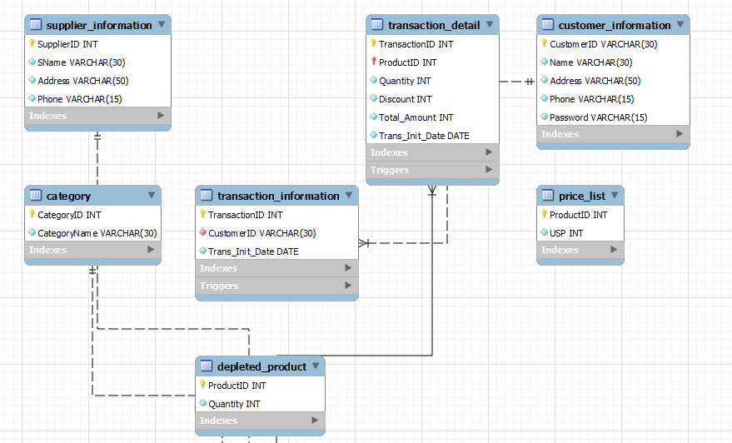

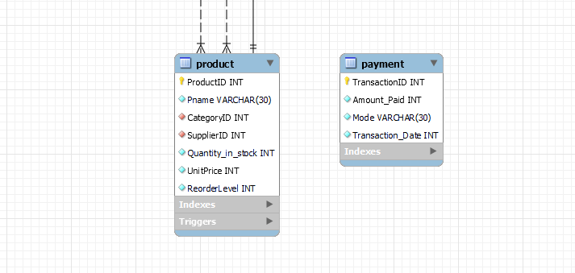

**4. Procedures**

discount_calc:

Parameters: product (INT), quant (INT), disc (OUT INT)

Description: Calculates discounts based on transaction amounts.

**5. Triggers**

depleted_check_update: Updates the depleted_product table based on product quantity thresholds.

supplier_check: Checks if the supplier exists before inserting a new product.

max_min_quantity: Enforces quantity thresholds and updates product stock levels during transaction insertion.

max_min_quantity_update: Enforces quantity thresholds and updates product stock levels during transaction updates.

customer_check: Checks if the customer exists before inserting a new transaction.

customer_check_update: Checks if the customer exists before updating a transaction.

decrease_quantity: Updates product stock levels when a transaction is deleted.

**6. Indexes**

The database includes primary and foreign key constraints to ensure data integrity and efficient querying.

**7. Conclusion**

The "Whole Sale System" database is designed to facilitate the management of wholesale operations efficiently. It provides a structured framework for storing and retrieving data related to products, customers, transactions, and payments. The inclusion of procedures and triggers enhances data processing and integrity, contributing to the overall effectiveness of the system.